Social Media Platform

1. **Creating the tables**

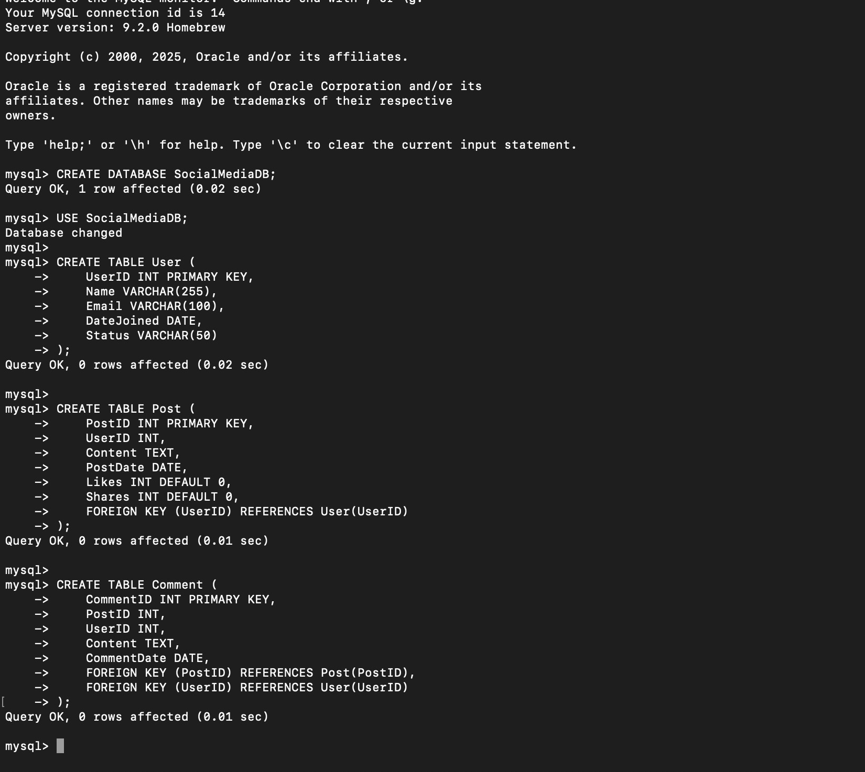

1. **Inserting sample data**

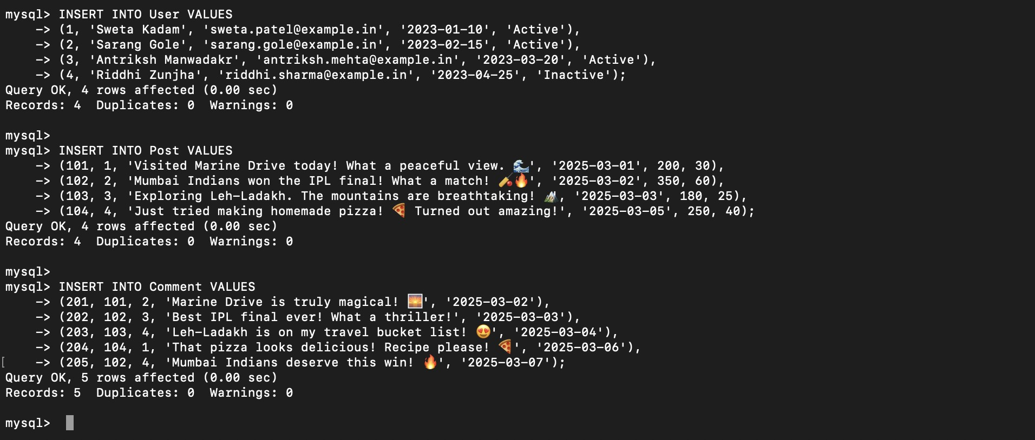

1. **Retrieve the most popular post based on likes**

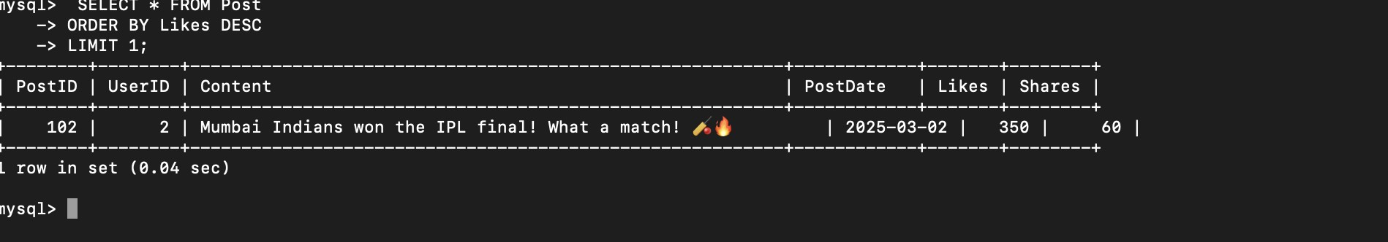

1. **Find users who posted the most content in the last month**

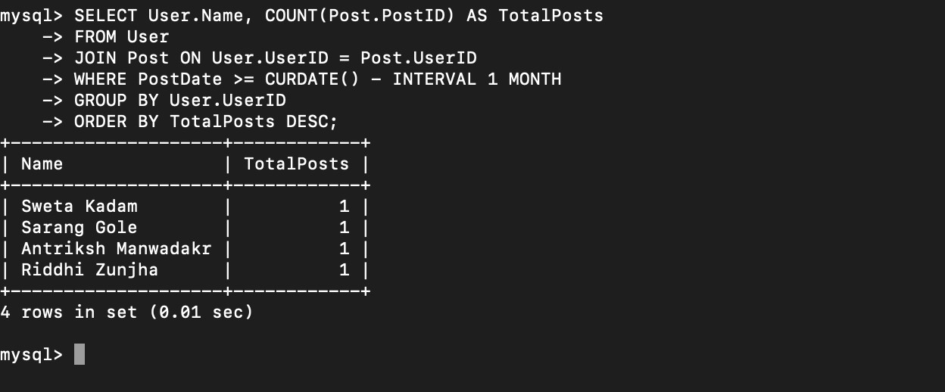

1. **Retrieve all comments made on a specific post**

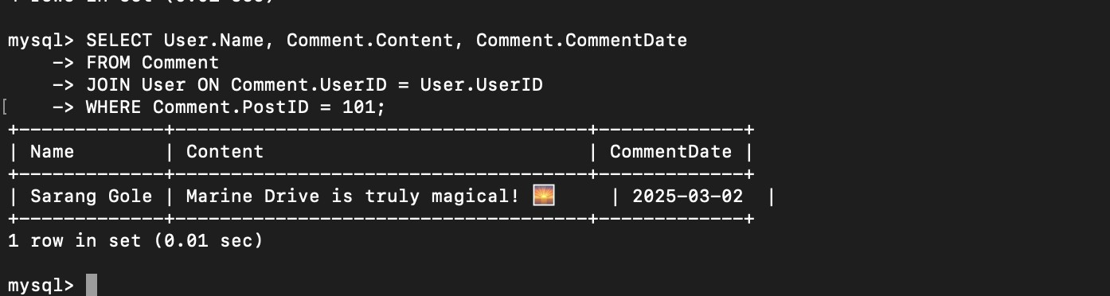

1. **Find the user with the highest number of shared posts**

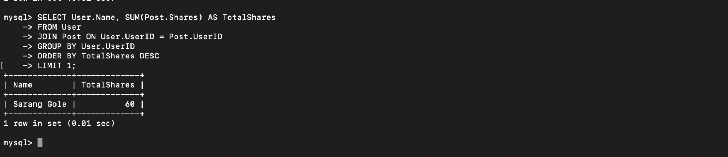

1. **Retrieve posts with more than 100 likes**

